Homework 2: Linear Algebra Review and
Geometric Representation

1.1 Linear Independence (6 points)
Show that the following sets of vectors are independent:

If the dot product of two vectors is zero and neither is the zero vector, then yes, the vectors are independent(HERE)
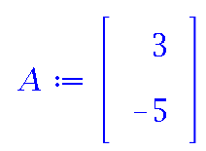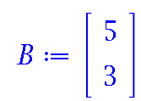 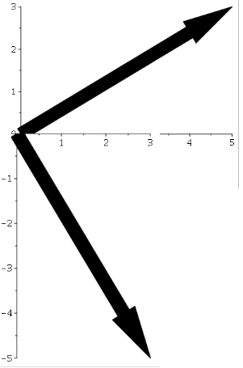 DotProduct(A, B) = 0

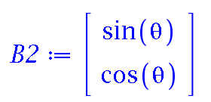
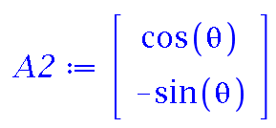
= 0

1.2 Cross Product (3 points)Show that the cross product is associative over scalars.
The scalar triple product is unchanged under a circular shift of its three operands
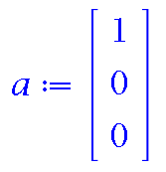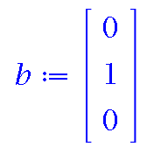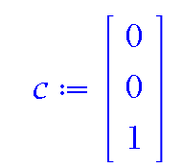

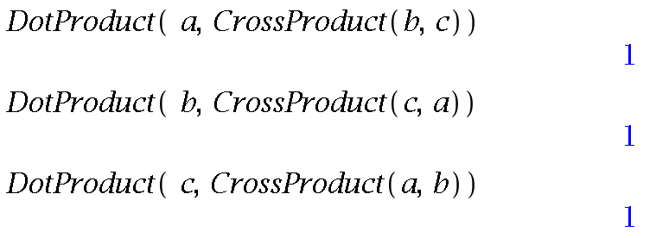

1.3 Special Orthogonal Group (9 points)

1.3.1 Commutative Property Using rotation matrices, prove that a 2D rotation is commutative, but that 3D rotation is not necessarily commutative.
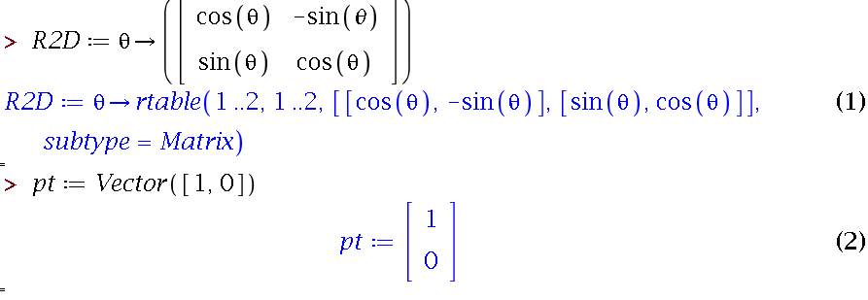

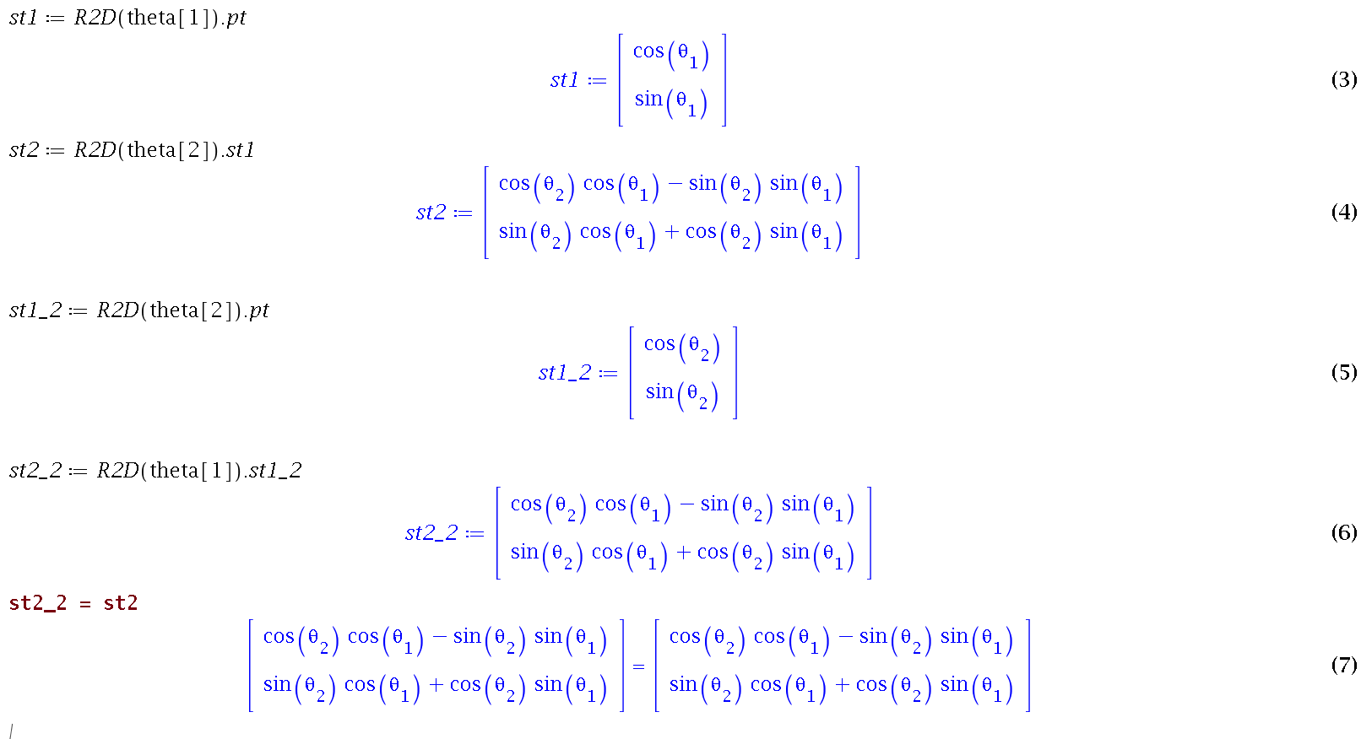
Thus with 2D Rotations with different order we ended up back at 90 Degrees
With 3D Rotations order matters
For 3D Transforms
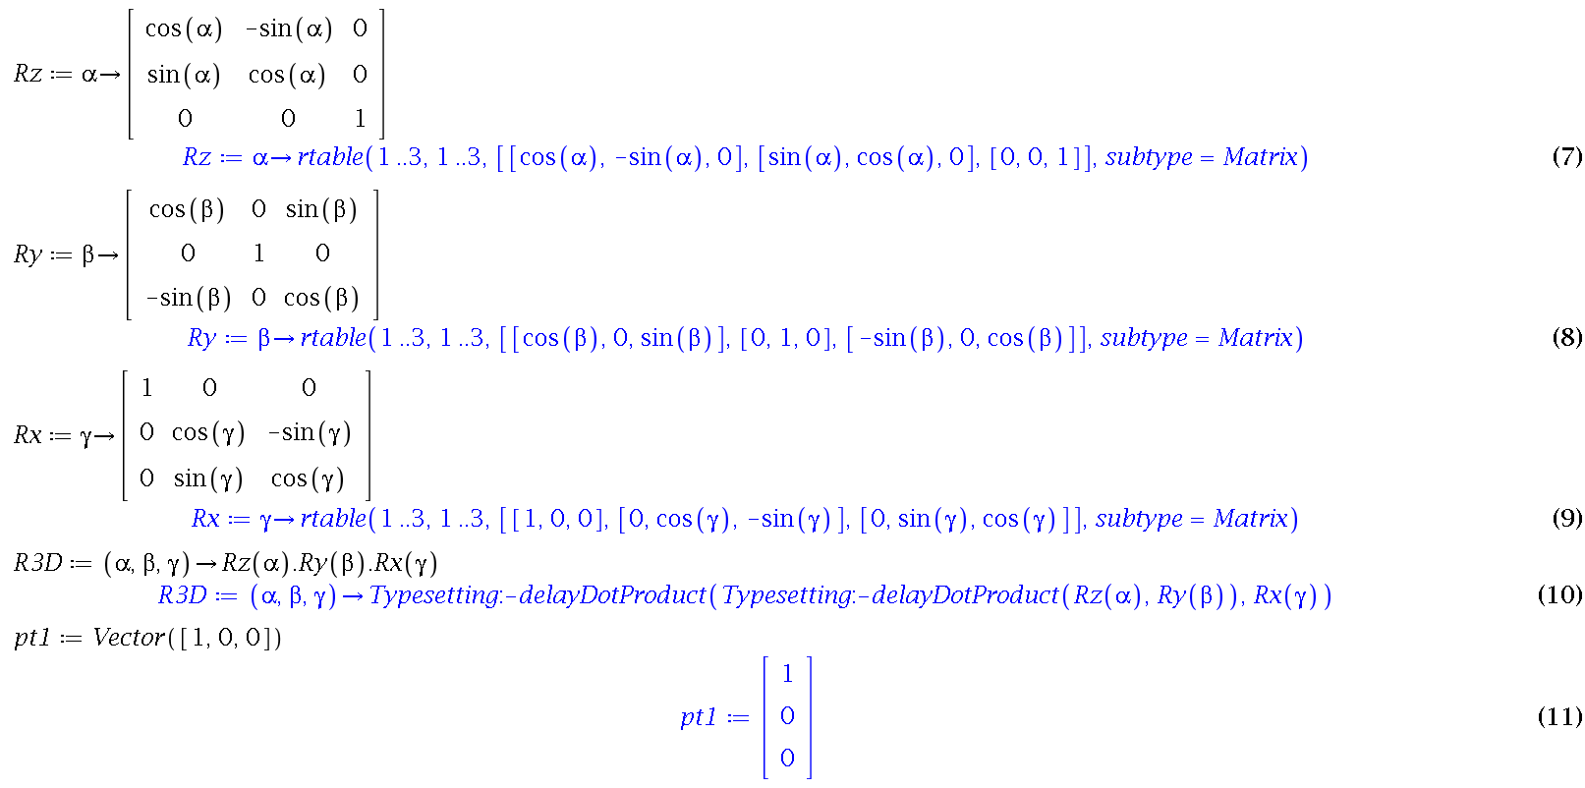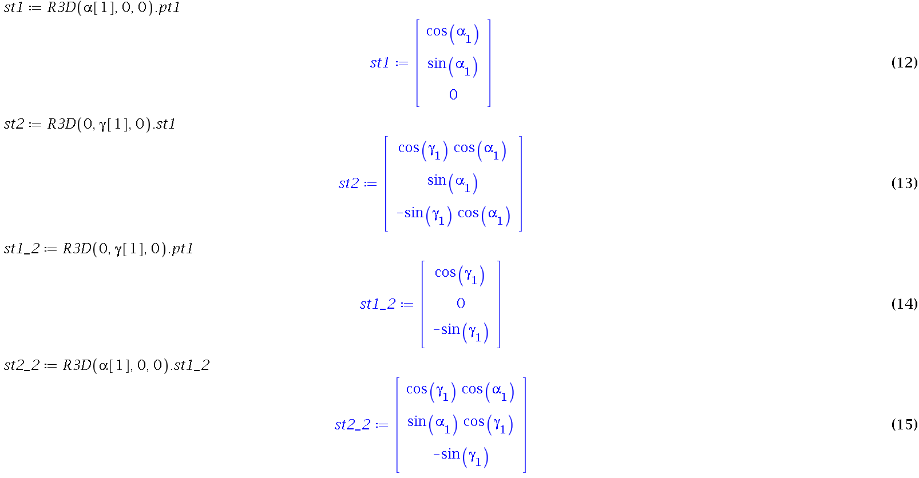
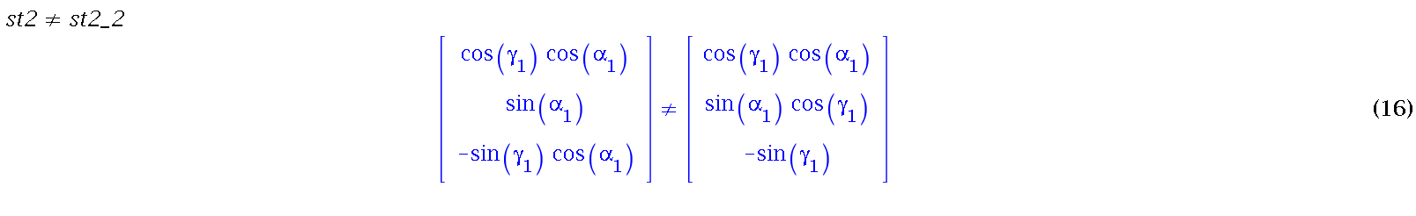
Thus we can see that the order does matter
1.3.2 Inverse
Express the inverse of the matrix R ∈ SO(3)

